Twentieth Annual Law and Religion Symposium Executive Committee
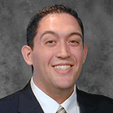

Master Schedule

Michelle Jeffs - Chair
Chase Thomas

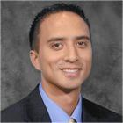

Recruitment

Chris Pieper – Co-Chair
Cherise Bacalski – Co-Chair
Kia Hohaia – Co-Chair
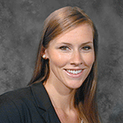
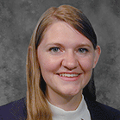
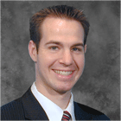

Rachel Bennion
Daniel Scow
Shantel Talbot
Transportation
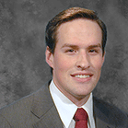
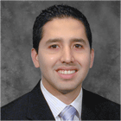

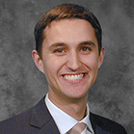


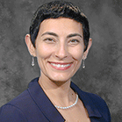

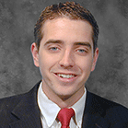
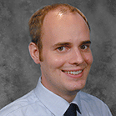

Erica Berrett - Chair
Lynn Nouri

Concierge/Hosting
Eimi Priddis – Co-Chair
Natalia Peterson – Co-Chair
Bryant Hinckley
James Heilpern
Documents
Joseph Ricks
John Anderson
Jorge Gavilanes – Co-Chair
James Egan – Co-Chair
Lynn Nouri
nourila@byulaw.net
(513) 180-8285
Erica Berrett - Chair
eberrett@byulaw.net
(702) 325-2039
Concierge/Hosting

