**Twentieth Annual Law and Religion Symposium Executive Committee**

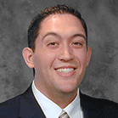**Master Schedule**

Michelle Jeffs - *Chair*

Chase Thomas

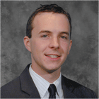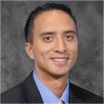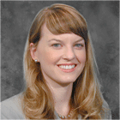**Recruitment**

Chris Pieper – *Co-Chair*

Cherise Bacalski – *Co-Chair*

Kia Hohaia – *Co-Chair*

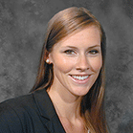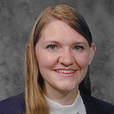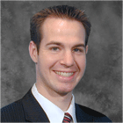

Rachel Bennion

Daniel Scow

Shantel Talbot

**Transportation**

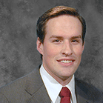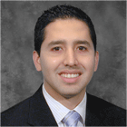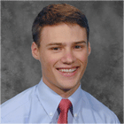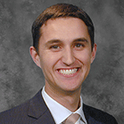

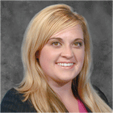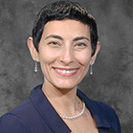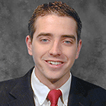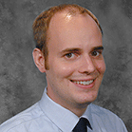

Erica Berrett - *Chair*

Lynn Nouri

**Concierge/Hosting**

Eimi Priddis – *Co-Chair*

Natalia Peterson – *Co-Chair*

Bryant Hinckley

James Heilpern

**Documents**

Joseph Ricks

John Anderson

Jorge Gavilanes – *Co-Chair*

James Egan – *Co-Chair*

Lynn Nouri  
[nourila@byulaw.net](mailto:nourila@byulaw.net)  
(513) 180-8285

Erica Berrett - *Chair*  
[eberrett@byulaw.net](mailto:eberrett@byulaw.net)  
(702) 325-2039

**Concierge/Hosting**