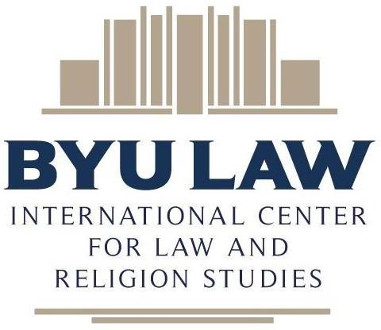

2025 ICLRS Events at Oxford:

Young Scholars Fellowship and

Concurrent Workshops

Organized by

The International Center for Law and Religion Studies

J. Reuben Clark Law School Brigham Young University

Provo, Utah 84602 USA

**Terms and Conditions**

The right to freedom of religion or belief (FoRB) is one of the most significant rights a human can possess. Since its founding on January 1, 2000, the International Center for Law and Religion Studies (the Center) has engaged in research and publications in the field of law and religion, built networks of opinion leaders internationally and in the United States, and participated in law reform processes that help safeguard the right to FoRB around the world.

The Center launched the Young Scholars Fellowship on Religion and the Rule of Law in 2018. Held annually at the University of Oxford, Christ Church, the Young Scholars Program is an advanced three-week training course in international and comparative law and religion for early-career academic professionals. Concurrent with the Young Scholars Program, the Center sponsors workshops at Christ Church focused on timely FoRB-related issues and publications. (Hereinafter the Young Scholars Program and concurrent workshops are referred to collectively as the Events.)

Among other things, these Terms and Conditions are intended to facilitate and ensure compliance with the proliferating laws protecting privacy and related rights in the United States and other similar data protection provisions in different jurisdictions (referred to collectively herein as Data Protection Regulations (DPR)) that may apply.

# Registration and processing of data

By registering for one or more of the Events, registrants accept that their data can be processed by the International Center for Law and Religion Studies and its affiliated Sponsors (collectively, the Organizers) for the purposes described in these Terms and Conditions.

During registration registrants are asked to share:

(a) **Identification data and other personal data** (including first name, last name, gender, nationality, country of residence, email, social media details, academic/professional title, position, organization name and type), as well as birthdate and passport information that may be needed to facilitate travel arrangements. Opportunity is also provided to indicate dietary requirements and other special needs. Not all information is required, although the information solicited helps the Organizers create a network of FoRB-inspired actors to engage in global agendas dealing with law and religion issues. The mandatory identification data is needed for logistical and organizational purposes (for example, an email address is needed for registration confirmation as well as a means of contact throughout the Events and follow-up). The non-mandatory other personal data will be used to facilitate registrants’ engagement with the Events, for historical archiving, and for anonymized statistical purposes.

(b) **Religious information** (including religious affiliation and religious title, when applicable). As a FoRB-related aggregatory, the Organizers have an interest in collecting data concerning religious affiliation from the registrants. This information is not mandatory but, if provided, will only be processed to help ensure maximum inclusion and nondiscrimination, and for anonymized statistical purposes. There will be no other disclosure of registrants’ religious information. Regarding this special category of data, the data subject is required to give specific consent according to Article 9(2)(a) of the GDPR. Data subjects will be deemed to consent to this data being collected if and when they submit such data.

By registering for the Events, registrants grant the Organizers permission to record, publish, share, or otherwise use any written, audio, photographic, video, or other electronic copies or sound or other images of presentation(s), interview(s), chat submission(s), programming, promotional materials, translations, or materials that emerge in connection with the Events in written, video, audio, photographic, or any other hard copy or electronic format, including on various websites of, or associated with, the Organizers.

Information regarding registrants will be processed by the Organizers and their affiliates. Only authorized personnel will have access to the data. Appropriate security and confidentiality measures are in place. The Organizers will share data with other Organizers, who agree to maintain the required data protections and who agree to use the data solely in the planning and communication related to the Events. The data will be deleted within a reasonable period after the purpose of the gathered information has been fulfilled, pursuant to each Organizer’s legally prescribed privacy policies.

Registrants have the right to request access to the data that the Organizers hold on them, to ask for rectification of personal data, if they are inaccurate or incomplete, and to object to the processing, as well as to withdraw their consent at any time, without cause and at no cost, by contacting the International Center for Law and Religion Studies at [info@iclrs.org](mailto:info@iclrs.org). The secretariat at that address serves as the data agent for dealing with questions or making corrections, changes, or deletions of data that has been collected and/or processed.

# The conditions

By registering, the data subject accepts the conditions by which the Organizers process data following legislation and policies applicable to the Organizers and their privacy policies.

# General rules

The Events are private, open to those invited and/or allowed by the Organizers.

Registrants agree not to violate any copyright, treaty, or legal restrictions in any country, the use of which would subject the Organizers or their affiliates to liability.

Registrants agree to abide by reasonable standards of courtesy, civility, and conduct (including any appropriate “streaming” conduct if participating online) during the Events.

Registrants waive the right to bring claims against any of the Organizers with respect to any matters to which registrants have granted permission or to which they have otherwise agreed under these Terms and Conditions.

The Organizers shall have the right to exclude registrants from the Events if any of the foregoing conditions are violated.